A MAJOR PROJECT REPORT ON

**COVID PORTAL WEBSITE**

*Submitted by*

##### **ANUPAM GUIN**(**1801299008**)

##### **ANIMESH KHAN**(**1801299005**)

**SUDHANSU SEKHAR JENA(1801299089)**

***In partial fulfillment for the award of the degree Of***

## BACHELOR OF TECHNOLOGY

***In***

#### COMPUTER SCIENCE AND ENGINEERING

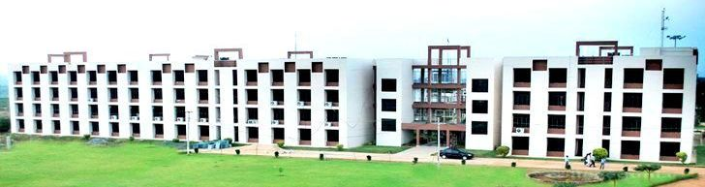



**TITE**

**TempleCity Institute of Technology and Engineering**

**Learning, Innovation and Development of New Applications**

## 



## BIJU PATNAIK UNIVERSITY OF TECHNOLOGY: ODISHA

**MAY, 2022**

A MAJOR PROJECT REPORT ON

**COVID PORTAL WEBSITE**

*Submitted by*

##### **ANUPAM GUIN**(**1801299008**)

##### **ANIMESH KHAN**(**1801299005**)

**SUDHANSU SEKHAR JENA(1801299089)**

***In partial fulfillment for the award of the degree Of***

## BACHELOR OF TECHNOLOGY

***In***

#### COMPUTER SCIENCE AND ENGINEERING





**TITE**

**TempleCity Institute of Technology and Engineering**

**Learning, Innovation and Development of New Applications**

## 



## BIJU PATNAIK UNIVERSITY OF TECHNOLOGY: ODISHA

**MAY, 2022**

Department of computer Science and Engineering



TEMPLECITY INSTITUTE OF TECHNOLOGY AND ENGINEERING

*DECLARATION*

I am hereby declare that the matter embodied in the major project report is original and has not been submitted by other universities/institution for the award of any degree/diploma.

##### 

***ANUPAM GUIN(1801299008)***

##### ***ANIMESH KHAN(1801299005)***

***SUDHANSU SEKHAR JENA(1801299005)***

Department of computer Science and Engineering



TEMPLECITY INSTITUTE OF TECHNOLOGY AND ENGINEERING

*CERTIFICATE*

##### This is certified that this entitled “**COVID PORTAL**” Submitted by Anupam Guin , Animesh Khan, Sudhansu Sekhar Jena of Templecity Institute of Technology and engineering(BPUT), Bhubaneswar towards fulfillment for the award of the degree of bachelor of technology in the department of Computer Science and Engineering is a confide record of the work done in my supervision and guidance.

Signature Signature

**Prof. Namita Das** **Prof. Namita Das**  (Guide) (Head of the Department)

Signature

(External Examiner)

**ACKNOWLEDGEMENT**

It is my pleasure to be indebted to various people, who directly or indirectly contributed in the development of this work and who influenced my thinking, behavior and acts during the course of study.

I also take this opportunity to express a deep sense of gratitude to **Prof.(Dr.) A.C Sahoo (Dean Academic)**  TITE, Khurda, Bhubaneswar, for his/her cordial support, valuable information and guidance, which helped me in completing this task through various stages.

I wish to express my profound and sincere gratitude to **Prof. Ruchismita Sahu**, Project coordinator, Department of Computer Science & Engineering, , who guided me into the intricacies of this project nonchalantly with matchless magnanimity.

I am thankful to **Prof.Namita Das**, Head of the Dept. of Computer Science & Engineering, for his/her support, cooperation, and motivation provided to me during the training for constant inspiration, presence and blessings.

I also extend my sincere appreciation to Faculty members are provided valuable suggestions and precious time in accomplishing my minor project report.

Lastly, I would like to thank the almighty and my parents for their moral support and friends with whom I shared my day-to-day experiences and received lots of suggestions those improved the quality of work.

Anupam Guin

Animesh Khan

Sudhansu Sekhar Jena

**ABSTRACT:-**

**PROFESSIONAL RESPONSIVE WEBSITE**

**INTRODUCTION:** This project is aimed at to make a Covid portal website .COVID-19 pandemic has resulted in disruptive impacts on teaching and learning experience around the world. In a particular context of project-based courses, where students need to interact and collaborate frequently, there appears additional challenges in implementing and learning from projects. Understanding the impact of COVID-19 on project-based courses does not only provide recommendations for preparing such courses in post-pandemic eras, but also has some implications for physical IT projects in industry. We investigated 30 student teams in Spring semester 2020, when COVID-19 measures were applied in the middle of the course. We adopted a mixed-method approach; a bottom-up analysis with a thematic analysis, and a top-down approach with attribution theory. We found that COVID19 measures introduced as external attributions to the course had direct and sudden impact manifestations on individual level, which leads to internal attributions, such as lack of motivation, lack of commitment, realization of usefulness of some online tools, and mental struggle. This creates an indirect impact on team, process and product factors in the course..

**OBJECTIVE:** Since early spring 2020, universities worldwide have been experiencing the disruptive impact of coronavirus disease (COVID-19)1 on their students. While many academic programs are facing with delaying graduation, students withdrawing from classes and intending to change majors around the world, Norwegian universities are applying various measures to support students to continue their study in a best possible way2 . The request on maintaining social distances is a game-changing factor for project based courses that emphasize teamwork and collaboration. Challenges to IT students working in groups for projects have always been persistent on regular basis, such as group dynamics, time and location convenience, commitment, and skills (Weland & Marshall 2020). However, these challenges are doubled with COVID-19, as the students had a short-noticed change in the way they communicate and collaborate while keeping up their motivation and the project progress. Students’ attitudes have always been a key determinant of their learning process and decisions in managing group work. This paper attempts to shed light on the impact of the COVID-19 and applied measures to customer-driven project courses at University of South-Eastern Norway (USN). We investigated and analyzed from course perspective, i.e. how students perform differently regarding to software development and student learning experience. Furthermore, we applied the attribution theory to understand internal and external factors that affect individual and team performance in student projects The paper is organized as follows: Section 1 is the introduction,

**TOOL USED IN FRONT END SIDE :**

* HTML
* CSS
* BOOTSTRAP
* JAVASCRIPT
* REACT JS
* REDUX and REDUX SAGA
* AXIOS
* GOOGLE MAPS
* APEX CHARTS

**TOOL USED IN BACKEND SIDE :**

**1) Java**

**2) Spring Boot**

**3) Rest API (Web Service )**

**4) Spring Security ( For Enable Security )**

**5) JSON web token (JWT)**

**6) Java persistent API ( JPA )**

**7) Oracle Database**

**TOOL USED IN Deployment SIDE :**

**1) GIT and GITHUB**

**2) Cloud Platform Heroku & HEROKU CLI**

**3) Postgres Sql In Production**

**OTHER TOOLS :**

**1) Postman**

**2) VS Code**

**3) Eclipse**

**OUTCOME:-**

**THE COVID PORTAL IS IN THIS TYPE IN PC :-**

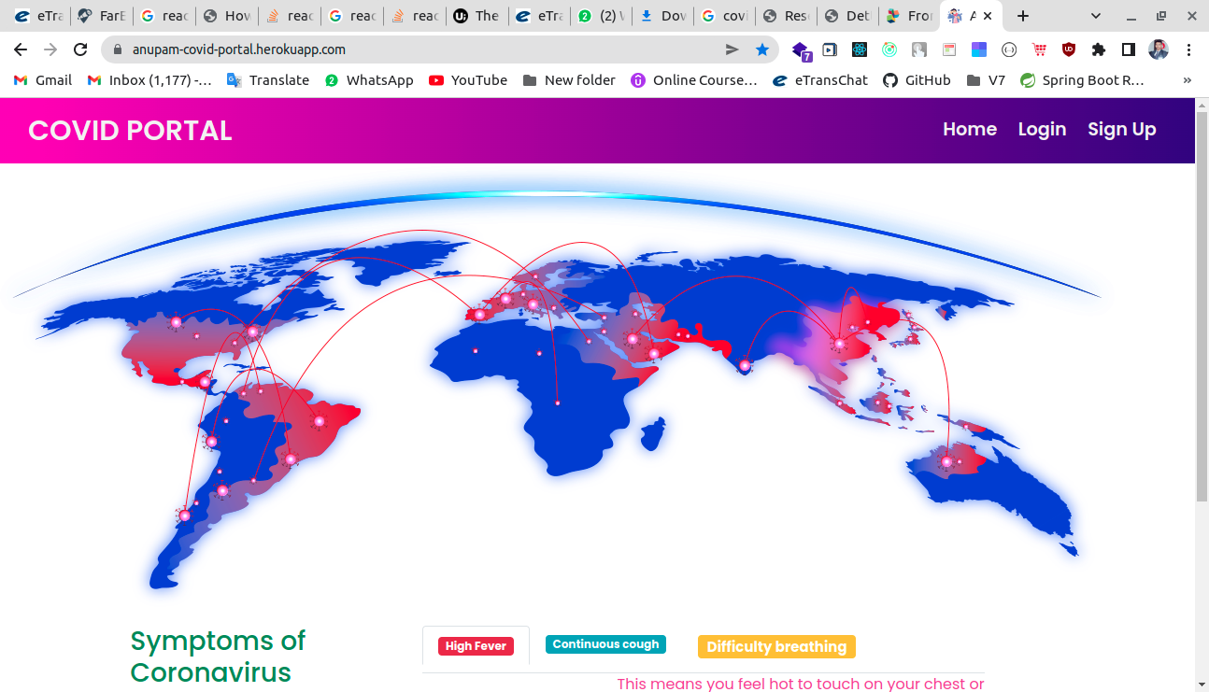

**SUBMITTED BY:** Anupam Guin , Animesh Khan , Sudhansu Sekhar Jena

**LIST OF TABLES**

TABLE OF CONTENTS

Chapter 1--------------------------------------------INDEX.HTML

Section 1.1 .................................................................. INTRODUCTION

Section 1.2 .................................................................. HEAD PART

Section 1.3 .................................................................. BODY PART

Subsection 1.3.a …………………………………….. MAIN NAV BAR

Subsection 1.3.b …………………………………… LANDING PAGE SECTION

Subsection 1.3.c …………………………………….. COURSES INTRO

Subsection 1.3.d …………………………………….. INTRO SECTION

Subsection 1.3.e …………………………………… COURSES SECTION

Subsection 1.3.f …………………………………….. LEARN MORE SECTION

Subsection 1.3.g …………………………………….. JAVA COURSE

Subsection 1.3.h …………………………………… ANGULAR COURSE

Subsection 1.3.i …………………………………….. BOOTSTRAP COURSE

Subsection 1.3.j …………………………………….. MAIN FOOTER

Subsection 1.3.k …………………………………… CONTACT MODAL

Subsection 1.3.l …………………………………….. OPTIONAL JAVASCRIPT

Chapter 2--------------------------------------------aBOUT.HTML

Section 2.1 .................................................................. INTRODUCTION

Section 2.2 .................................................................. HEAD PART

Section 2.3 .................................................................. BODY PART

Subsection 2.3.a …………………………………….. MAIN NAV BAR

Subsection 2.3.b …………………………………… ABOUT US INTRO

Subsection 2.3.c …………………………………….. ABOUT US SECTION

Subsection 2.3.d …………………………………….. TRAINERS SECTION

Subsection 2.3.e …………………………………… MAIN FOOTER

Subsection 2.3.f …………………………………….. CONTACT MODAL

Subsection 2.3.g …………………………………….. OPTIONAL JAVASCRIPT

Chapter 3-------------------------------------------- COURSES.HTML

Section 3.1 .................................................................. INTRODUCTION

Section 3.2 .................................................................. HEAD PART

Section 3.3 .................................................................. BODY PART

Subsection 3.3.a …………………………………….. MAIN NAV BAR

Subsection 3.3.b …………………………………… COURSES SECTION

Subsection 3.3.c …………………………………….. COURSES SERVICE SECTION

Subsection 3.3.d …………………………………….. COURSE DETAILS SECTION

Subsection 3.3.e …………………………………… PRICE DETAILS SECTION

Subsection 3.3.f …………………………………….. MAIN FOOTER

Subsection 3.3.g …………………………………….. CONTACT MODAL

Subsection 3.3.h …………………………………… OPTIONAL JAVASCRIPT

Chapter 4---------------------------------------------CONTACT.HTML

Section 4.1 .................................................................. INTRODUCTION

Section 4.2 .................................................................. HEAD PART

Section 4.3 .................................................................. BODY PART

Subsection 4.3.a …………………………………….. MAIN NAV BAR

Subsection 4.3.b …………………………………… CONTACT INTRO

Subsection 4.3.c …………………………………….. CONTACT SECTION

Subsection 4.3.d …………………………………….. CONTACT MORE

Subsection 4.3.e …………………………………… MAIN FOOTER

Subsection 4.3.f …………………………………….. CONTACT MODAL

Subsection 4.3.g …………………………………….. OPTIONAL JAVASCRIPT

Chapter 5---------------------------------------------STYLES.CSS

Section 5.1 .................................................................. INTRODUCTION

Section 5.2 .................................................................. LANDING PAGE STYLES

Section 5.3 .................................................................. COURSES IMAGE

Section 5.4 .................................................................. TRAINER IMAGE

Section 5.5 .................................................................. COURSE SECTION

**INTRODUCTION :-**

COVID-19 had impact on the students’ attitude and effort toward their group project work in the context of our study and, thus, influenced the outcomes of the carried project tasks in the project course. Despite the significant relationship between the attitude and effort in the context of higher education, it has been rarely addressed in previous research (Li 2012). To explain the relationship between the students’ effort and achieving the outcomes of the tasks carried out in the project, attribution theory is a fit. Attribution theory considers individuals as active beings that “seek to understand and master their environment and themselves” (Li 2012). Thus, the behavior of individuals and the outcomes of their effort can be attributed to (Heider 1958; Weiner 1979): (1) external attributions, which are factors that are external to the individual and are difficult to control (e.g., difficulty of carrying out the project tasks due to COVID-19 caused teaching and group activities go online), and,(2) internal attributions, which are factors that are within the individual’s ability to control (e.g., motivation and effort to collaborate with others to carry out the project tasks) visitors to the right site. Responsiveness takes much of the stress out of managing a business website.

**PROBLEM STATEMENT :-**

The outbreak of COVID-19 and the measures applied to the project course occurred between week 6 to week 8 of the course. We have had the same intended learning outcomes, assignments and final project presentations for students. However, we adjusted some teaching activities due to the closure of our campuses. Teaching was required to be maintained digitally from March 16, 2020. All exams are turned into digital exams. The direct impact into the courses include: • Supervision meeting that would occur physically bi-monthly for each team now turned into virtual meetings, scheduled bi-monthly

**PROJECT SCHEDULING:-**

This document provides a scalable scheduling tool and associated schedule development, analysis, and monitoring methods that can be used by implementining agencies (IA) to prepare, monitor and report project schedules our project is not that complex so we will not use very complex scheduling method.

**CHAPTER – 1**

**INDEX.HTML**

**Section 1.1**

**INTRODUCTION :-**

**First when we open the url where this site was deployed then it will show you a home page that for every one . Where you can see a amazing webpage with some basic design elements. And If a user want to use this portal then he have to login this portal , if he is the first time user that he have to sign up then in the bellow email id he get one otp then by this otp he can create his own user. Then by the username and password he can open the portal. Where he can see each features of this portal. The whole application is so much secure like an Production site. So no any hacker can attack this site and break it’s bridges.**

**Section 1.2**

**HEAD PART :-**

Here we use JWT token to secure this application and each and every API is taking JWT token then validated and if validate then it enters . To Each end point is Encrypted here by using Spring Security and Json web token.

**HEAD PART CODE :-**

import React from "react";

import ReactDOM from "react-dom";

import "./index.css";

import App from "./App";

import reportWebVitals from "./reportWebVitals";

import { Provider } from "react-redux";

import { applyMiddleware, compose, createStore } from "redux";

import CreateSagaMiddleware from "redux-saga";

import RootReducer from "./rootReducer";

import RootSaga from "./rootSaga";

import { persistStore, persistReducer } from "redux-persist"; // imports from redux-persist

import storage from "redux-persist/lib/storage"; // defaults to localStorage for web

import { PersistGate } from "redux-persist/integration/react";

import logger from "redux-logger";

import axios from "axios";

import { logout } from "./components/Api/UserApi";

import { SET_CURRENT_USER } from "./components/Constants/UserConstants";

import setJWTToken from "./components/security/setJWTToken";

import jwt_decode from "jwt-decode";

import { SET_GLOBAL_ALERT_MODAL } from "./components/GlobalAlertModal/globarAlertModalAction";

const persistConfig = {

// configuration object for redux-persist

key: "root",

storage, // define which storage to use

blacklizst: ["userReducer"],

};

const persistedReducer = persistReducer(persistConfig, RootReducer);

const composeEnhancers = window.__REDUX_DEVTOOLS_EXTENSION_COMPOSE__ || compose;

const sagaMiddleware = CreateSagaMiddleware();

const middleware = applyMiddleware(sagaMiddleware, logger);

const store = createStore(

// RootReducer,

persistedReducer,

composeEnhancers(middleware)

);

sagaMiddleware.run(RootSaga);

const persistor = persistStore(store); // used to create the persisted store, persistor will be used in the next step

const jwtToken = localStorage.jwtToken;

if (jwtToken) {

setJWTToken(jwtToken);

const decoded_jwtToken = jwt_decode(jwtToken);

store.dispatch({

type: SET_CURRENT_USER,

payload: decoded_jwtToken,

});

const currentTime = Date.now() / 1000;

if (decoded_jwtToken.exp < currentTime) {

// handle logout

console.log(decoded_jwtToken, "anu");

store.dispatch(logout());

window.location.href = "/";

}

}

// For any backend error

axios.interceptors.response.use(

function (response) {

return response;

},

function (error) {

try {

if (404 === error.response.status) {

console.warn("404 Error Came ");

let endpoint = error.response.config.url.split("/")[3];

store.dispatch({

type: SET_GLOBAL_ALERT_MODAL,

payload: {

show: true,

type: "warning",

title: `Error with ${endpoint} endpoint`,

message: `${endpoint} endpoint is unresponsive , Please contact to admin`,

},

});

} else if (500 === error.response.status) {

let endpoint = error.response.config.url.split("/")[3];

console.log(endpoint, " ", error.response.config.url);

store.dispatch({

type: SET_GLOBAL_ALERT_MODAL,

payload: {

show: true,

type: "info",

title: `Error with ${endpoint} endpoint`,

message: `${endpoint} endpoint is unresponsive , Please contact to admin`,

},

});

} else if (401 === error.response.status) {

let endpoint = error.response.config.url.split("/")[3];

console.log(endpoint, " ", error.response.config.url);

store.dispatch({

type: SET_GLOBAL_ALERT_MODAL,

payload: {

show: true,

type: "info",

title: `You are Unauthoried`,

message: `Please give the right Username & Password`,

},

});

} else if (409 === error.response.status) {

let endpoint = error.response.config.url.split("/")[3];

console.log(error.response.data, "eee");

const er = error.response.data;

let errMsg = "";

if (er.name) {

errMsg += er.name;

}

if (er.email) {

errMsg += " " + er.email;

}

// console.log(endpoint, " ", error.response.config.url);

store.dispatch({

type: SET_GLOBAL_ALERT_MODAL,

payload: {

show: true,

type: "info",

title: `Fill the Form Correctly`,

message: `${errMsg}`,

},

});

} else return Promise.reject(error);

} catch (err) {

console.log("error came in index.js");

}

}

);

**Section 1.2**

**BODY PART :-**

Each and every Components is Secure by JWT token that is stored in Local Storage

***Subsection 1.3.a***

**MAIN NAV BAR :-**

In between main nav bar there are so many html tags are used here like nav tag , div tag, anchor tag and inbetween anchor tag there is a image tag.buttons are used here inbetween botton there is a span tag .Then the ul tag and li tags are used here to make a nav bar.

*import React, { Component } from "react";*

class Home extends Component {

render() {

return (

<>

{/* <div className="title">Responsive Dropdown and Mega Menu</div>

<div className="sub-title">using only HTML & CSS</div> */}

<img src="/images/world.png" alt="Corona" style={{ width: "100%" }} />

{/* <img src="/images/02.jpg" alt="Corona" />

<br />

<img src="/images/corona2.png" alt="Corona" />

<br />

<img src="/images/corona3.png" alt="Corona" />

<br /> */}

<div className="container">

<div className="row">

<div className="col-lg-4 col-sm-12 col-md-12 mb-5">

<h3 className="text-success ">Symptoms of Coronavirus</h3>

The most common symptoms of COVID-19 are fever, tiredness, and dry

cough. Some patients may have aches and pains, nasal congestion,

runny nose, sore throat or diarrhea. These symptoms are usually

mild and begin gradually. Also the symptoms may appear 2-14 days

after exposure.

</div>

<div className="col-lg-8 col-sm-12 col-md-12">

<ul className="nav nav-tabs" id="myTab" role="tablist">

<li className="nav-item" role="presentation">

<button

className="nav-link active"

id="home-tab"

data-bs-toggle="tab"

data-bs-target="#home"

type="button"

role="tab"

aria-controls="home"

aria-selected="true"

>

<span className="badge badge-danger"> High Fever</span>

</button>

</li>

<li className="nav-item" role="presentation">

<button

className="nav-link"

id="profile-tab"

data-bs-toggle="tab"

data-bs-target="#profile"

type="button"

role="tab"

aria-controls="profile"

aria-selected="false"

>

<h6>

<span className="badge badge-info">Continuous cough</span>

</h6>

</button>

</li>

<li className="nav-item" role="presentation">

<button

className="nav-link"

id="contact-tab"

data-bs-toggle="tab"

data-bs-target="#contact"

type="button"

role="tab"

aria-controls="contact"

aria-selected="false"

>

<h5>

<span className="badge badge-warning">

Difficulty breathing

</span>

</h5>

</button>

</li>

</ul>

<div className="tab-content" id="myTabContent">

<div

className="tab-pane fade show active"

id="home"

role="tabpanel"

aria-labelledby="home-tab"

>

<div className="row">

<div className="col-4">

<img

alt="Fever"

src="images/fever.png"

width="100px"

height="100px"

style={{ marginLeft: "20px", marginTop: "20px" }}

/>

</div>

<div className="col-8">

<p

style={{

color: "#e74292",

fontSize: "1rem",

fontFamily: "Times New Roman', Times, serif",

}}

>

This means you feel hot to touch on your chest or back

(you do not need to measure your temperature). It is a

common sign and also may appear in 2-10 days if you

affected.

</p>

</div>

</div>

</div>

<div

className="tab-pane fade"

id="profile"

role="tabpanel"

aria-labelledby="profile-tab"

>

<div className="row">

<div className="col-4">

<img

alt="Fever"

src="images/cough.png"

width="100px"

height="100px"

style={{ marginLeft: "20px", marginTop: "20px" }}

/>

</div>

<div className="col-8">

<p

style={{

fontSize: "1rem",

fontFamily: "Times New Roman', Times, serif",

}}

>

This means coughing a lot for more than an hour, or 3 or

more coughing episodes in 24 hours (if you usually have

a cough, it may be worse than usual).

</p>

</div>

</div>

</div>

<div

className="tab-pane fade"

id="contact"

role="tabpanel"

aria-labelledby="contact-tab"

>

<div className="row">

<div className="col-4">

<img

alt="Fever"

src="images/breathing.png"

width="100px"

height="100px"

style={{ marginLeft: "20px", marginTop: "20px" }}

/>

</div>

<div className="col-8">

<p

style={{

color: "blue",

fontSize: "1rem",

fontFamily: "Times New Roman', Times, serif",

}}

>

Around 1 out of every 6 people who gets COVID-19 becomes

seriously ill and develops difficulty breathing or

shortness of breath.

</p>

</div>

</div>

</div>

</div>

</div>

</div>

</div>

</>

);

}

}

export default Home;

***Subsection 1.3.b***

***Login page***

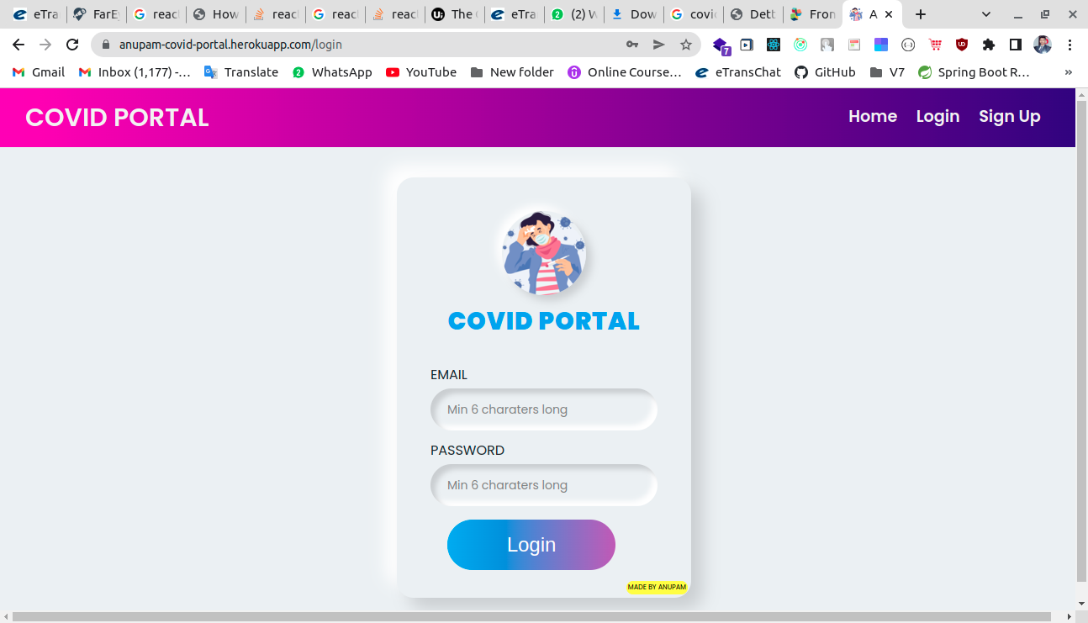

**LANDING PAGE SECTION :-**

*import React, { Component } from "react";*

import { connect } from "react-redux";

import { do_login } from "../Actions/UserActions";

import "./css/Login.css";

class Login extends Component {

constructor(props) {

super(props);

this.state = {

username: "",

password: "",

};

}

onChange = (e) => {

this.setState({ [e.target.name]: e.target.value });

};

onSubmit = (e) => {

const loginData = {

username: this.state.username,

password: this.state.password,

};

this.setState({ username: "", password: "" });

console.log(loginData);

this.props.do_login(loginData);

};

componentWillReceiveProps(nextProps) {

console.warn(nextProps, "next Props");

if (nextProps.userReducer.loginResponse.success)

this.props.history.push("/");

}

render() {

return (

<div className="allbody">

<div className="containers">

<div className="brand-logo"></div>

<div className="brand-title">COVID PORTAL</div>

<div className="inputs">

<label className="onlyLabel one">EMAIL</label>

<input

type="text"

placeholder="Min 6 charaters long"

className="onlyInput one"

name="username"

onChange={this.onChange}

value={this.state.username}

/>

<label className="onlyLabel one">PASSWORD</label>

<input

type="password"

placeholder="Min 6 charaters long"

className="one onlyInput"

name="password"

onChange={this.onChange}

value={this.state.password}

/>

{/* <button type="submit" className="one onlyButton">

LOGIN

</button> */}

<div className="mt-3 button_great content">

<a

id="videolink"

className="a btn-get-started"

onClick={this.onSubmit}

>

Login

</a>

</div>

</div>

<a

target="_blank"

href="https://www.linkedin.com/in/anupam-guin-948b4718b/?originalSubdomain=in"

className="myName"

>

MADE BY ANUPAM

</a>

</div>

</div>

);

}

}

export default connect(mapStateToProps, mapDispatchToProps)(Login);

***Subsection 1.3.c***

Registration Page

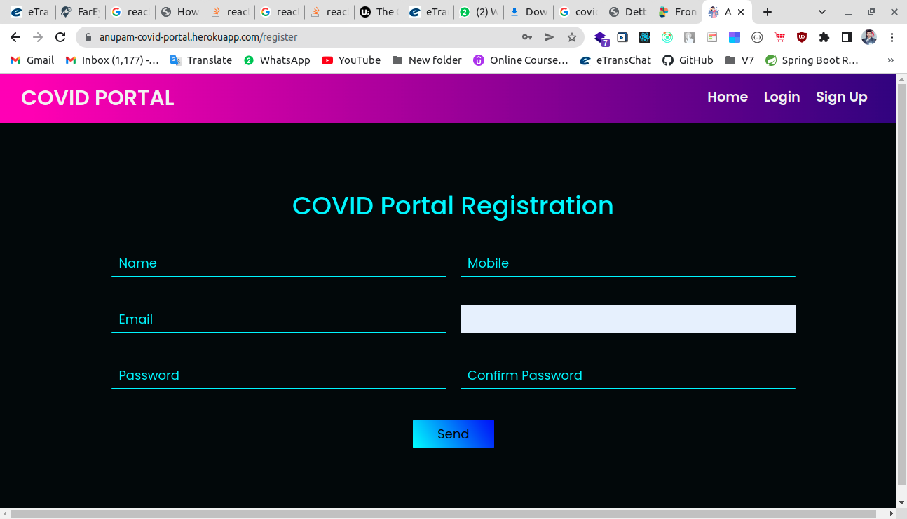

***Subsection 1.3.d***

**INTRO SECTION :-**

class Register extends Component {

constructor(props) {

super(props);

this.state = {

name: "",

email: "",

mobile: "",

age: 0,

password: "",

confirmPassword: "",

suspensePage: "hide-spin",

};

}

onChange = (event) => {

this.setState({ [event.target.name]: event.target.value });

};

Click = () => {

const regData = {

name: this.state.name,

email: this.state.email,

mobile: this.state.mobile,

age: this.state.age,

password: this.state.password,

confirmPassword: this.state.confirmPassword,

};

this.setState({ suspensePage: "show-spin" });

this.props.do_register(regData, this.props);

this.setState({

name: "",

email: "",

mobile: {},

age: {},

password: "",

confirmPassword: "",

});

};

componentWillReceiveProps(nextProps) {

console.log("prpps", nextProps);

this.setState({ suspensePage: "hide-spin" });

this.props.registerResponse && this.props.history.push("/otp");

}

***Subsection 1.3.e***

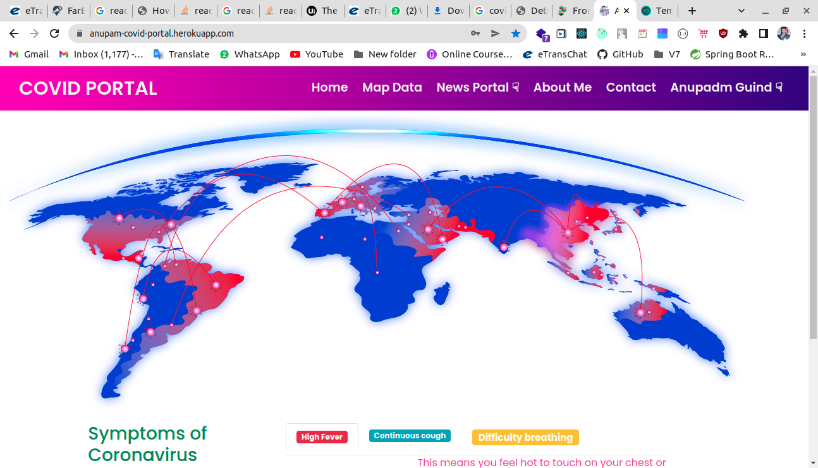

***Subsection 1.3.g***

**JAVA COURSE :-**

In between java course the used tags are section tag, div tag, heading tag, paragraph tag, anchor tag.Then this part is over.

<!-- Java Course -->

    <section class="p-4">

        <div class="container">

            <div class="row align-items-center">

                <div class="col-md-6">

                    <h2 class="font-weight-bold text-warning">The Complete Java Course</h2>

                    <p class="lead">I advice you to go for SoftTech , as many of my classmates and friends have joined that. All

This is the Home page after Login with a valid Credentials

***Subsection 1.3.h***

**ANGULAR COURSE :-**

In between angular course the used tags are section tag, div tag, heading tag, paragraph tag, anchor tag.Then this part is over.

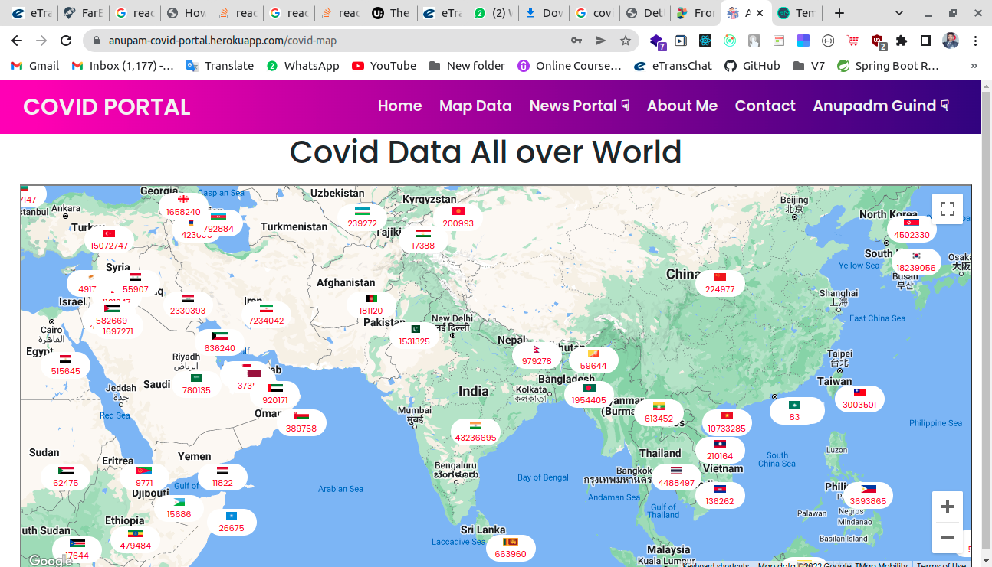

***Subsection 1.3.i***

**BOOTSTRAP COURSE :-**

In between bootstrap course the used tags are section tag, div tag, heading tag, paragraph tag, anchor tag.Then this part is over.

<!-- Bootstrap Course -->

    <section class="p-4">

        <div class="container">

            <div class="row align-items-center">

                <div class="col-md-6">

                    <h2 class="font-weight-bold text-warning">The Bootstrap Course</h2>

                    <p class="lead"> I advice you to go for SoftTech , as many of my classmates and friends have joined that. All of them have got placed at min. Pac

import axios from "axios";

import React, { Component } from "react";

import { FirstCard } from "./CovidWorldCase-Component/FirstCard";

import { SecondCard } from "./CovidWorldCase-Component/SecondCard";

import { ThirdCard } from "./CovidWorldCase-Component/ThirdCard";

class CovidWorldCase extends Component {

constructor(props) {

super(props);

this.state = {

covidAll: {},

};

}

componentDidMount() {

this.coronaAll();

}

coronaAll = async () => {

const resp = await axios.get("https://corona.lmao.ninja/v2/all");

console.log(resp.data);

this.setState({ covidAll: resp.data });

};

render() {

const { covidAll } = this.state;

const date = new Date(parseInt(covidAll.updated));

const lastUpdated = date.toString();

let updateMSG = "Last updated " + lastUpdated;

return (

<>

<div className="row" style={{ width: "100vw", marginTop: "2rem" }}>

<div className="col-sm-12 col-md-12 col-lg-4">

<FirstCard data={covidAll} updateMSG={updateMSG} />

</div>

<div className="col-sm-12 col-md-12 col-lg-4">

<SecondCard data={covidAll} updateMSG={updateMSG} />

</div>

<div className="col-sm-12 col-md-12 col-lg-4">

<ThirdCard data={covidAll} updateMSG={updateMSG} />

</div>

</div>

</>

);

}

}

export default CovidWorldCase;

***Subsection 1.3.j***

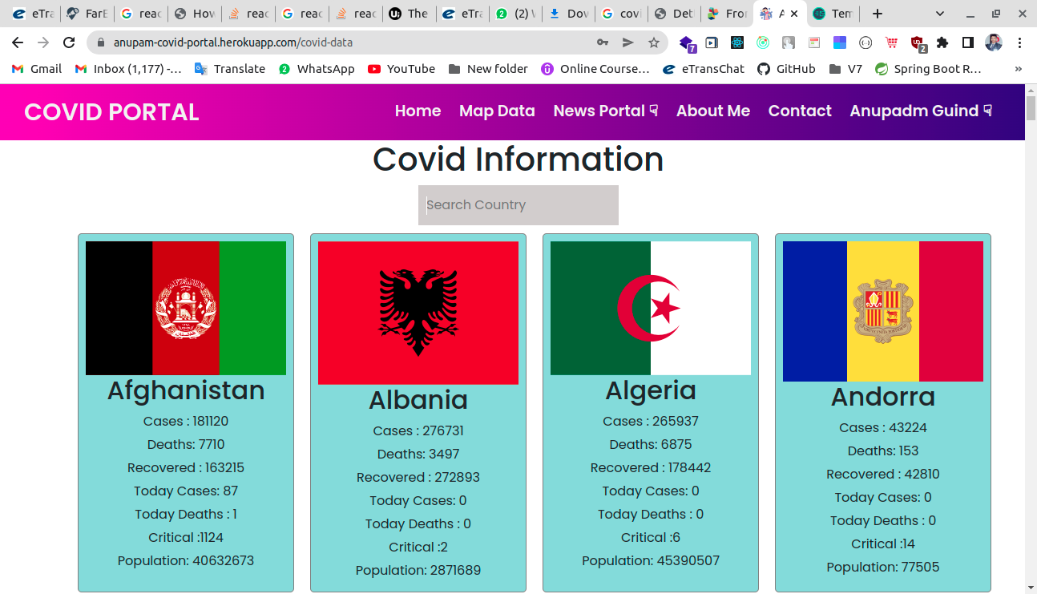***Subsection 1.3.k***

import axios from "axios";

import React, { Component } from "react";

import { CardList } from "./CovidDataComponent/CardList-Component";

import { SearchBox } from "./CovidDataComponent/Search-Component";

class CovidData extends Component {

constructor(props) {

super(props);

this.state = {

covidAll: {},

covidCountries: [],

searchField: "",

};

}

componentDidMount() {

this.coronaCountriesApi();

}

coronaCountriesApi = async () => {

const resp = await (

await axios.get("https://corona.lmao.ninja/v2/countries")

).data;

console.log(resp);

this.setState({ covidCountries: resp });

};

onSearchChange = (e) => {

this.setState({ searchField: e.target.value });

};

render() {

const { covidCountries, searchField } = this.state;

const filterCountries = covidCountries.filter((item) =>

item.country.toLowerCase().includes(searchField.toLowerCase())

);

return (

<div style={{ textAlign: "center" }} className="cvdData">

<h1>Covid Information</h1>

<SearchBox onSearchChange={this.onSearchChange} />

<CardList countriesData={filterCountries} />

</div>

);

}

}

export default CovidData;

***Subsection 1.3.l***

This is the About page

import React, { Component } from "react";

class About extends Component {

render() {

return (

<div

className="container"

style={{ width: "100vw", textAlign: "center" }}

>

{/* <div className>

<h1 style={{ textAlign: "center" }}>My Resume</h1>

</div> */}

<img src="/images/resume.jpg" alt="RESUME" width="70%" height="40%" />

</div>

);

}

}

export default About;

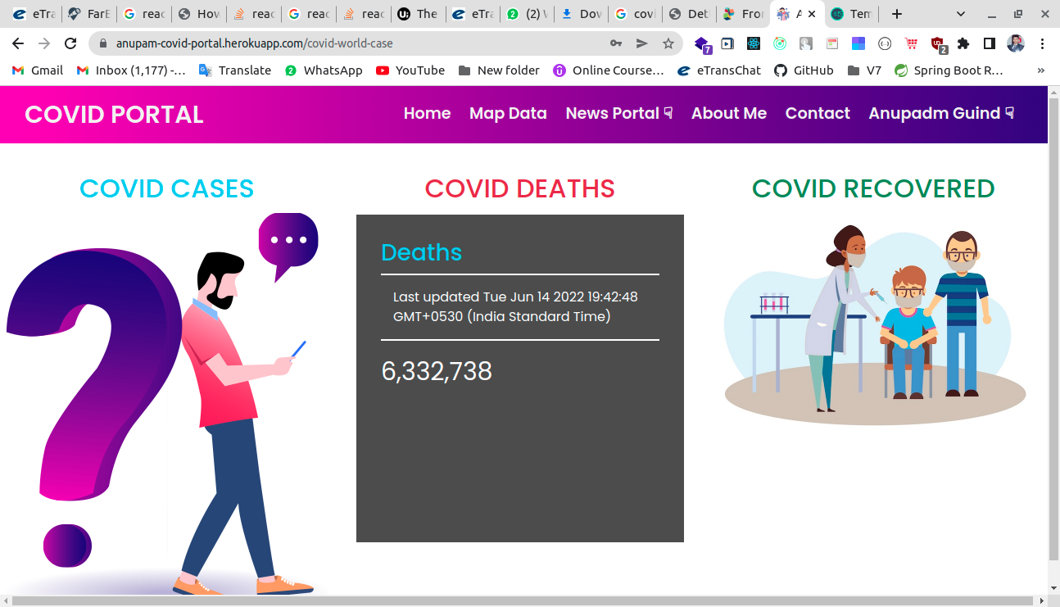

OUTPUT OF THE HOME PAGE :-

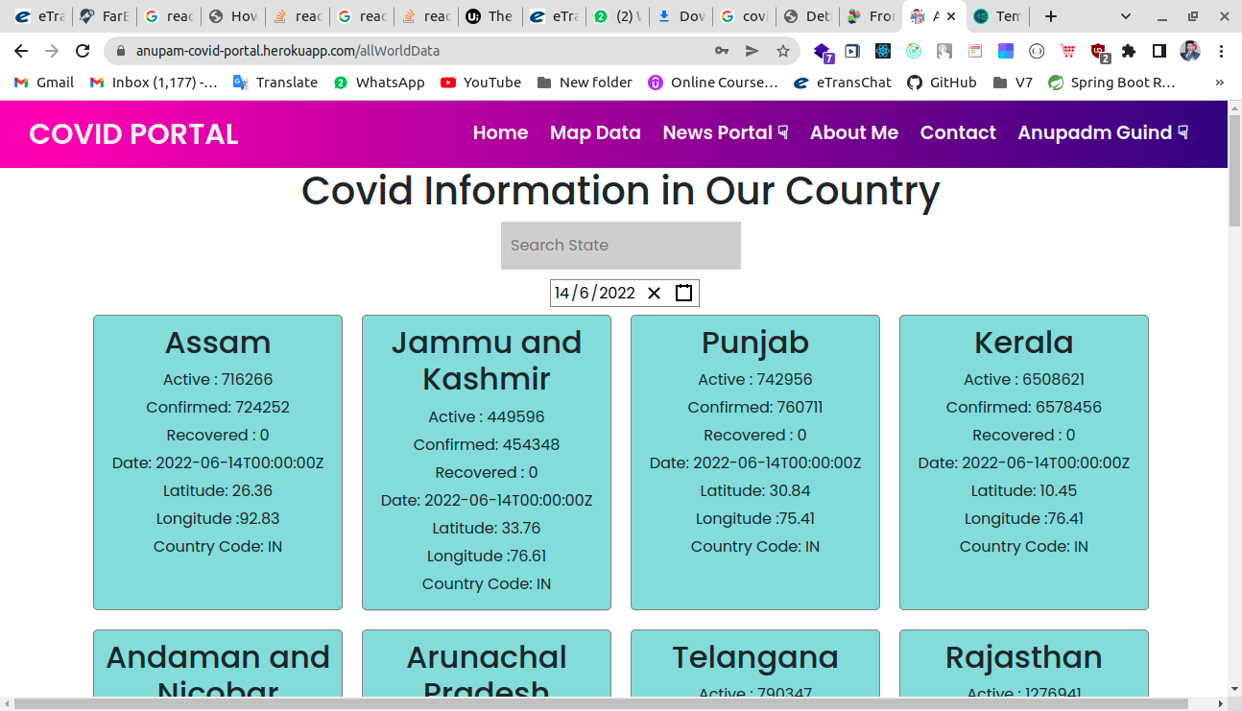

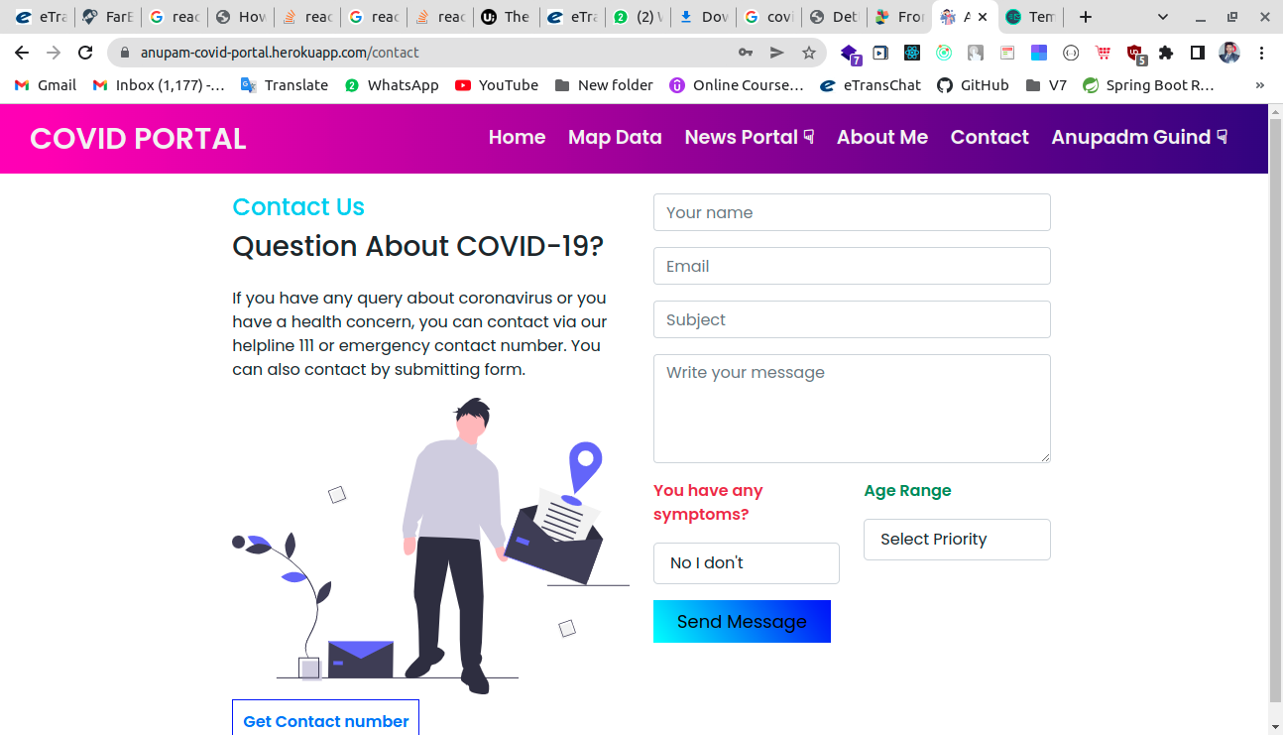







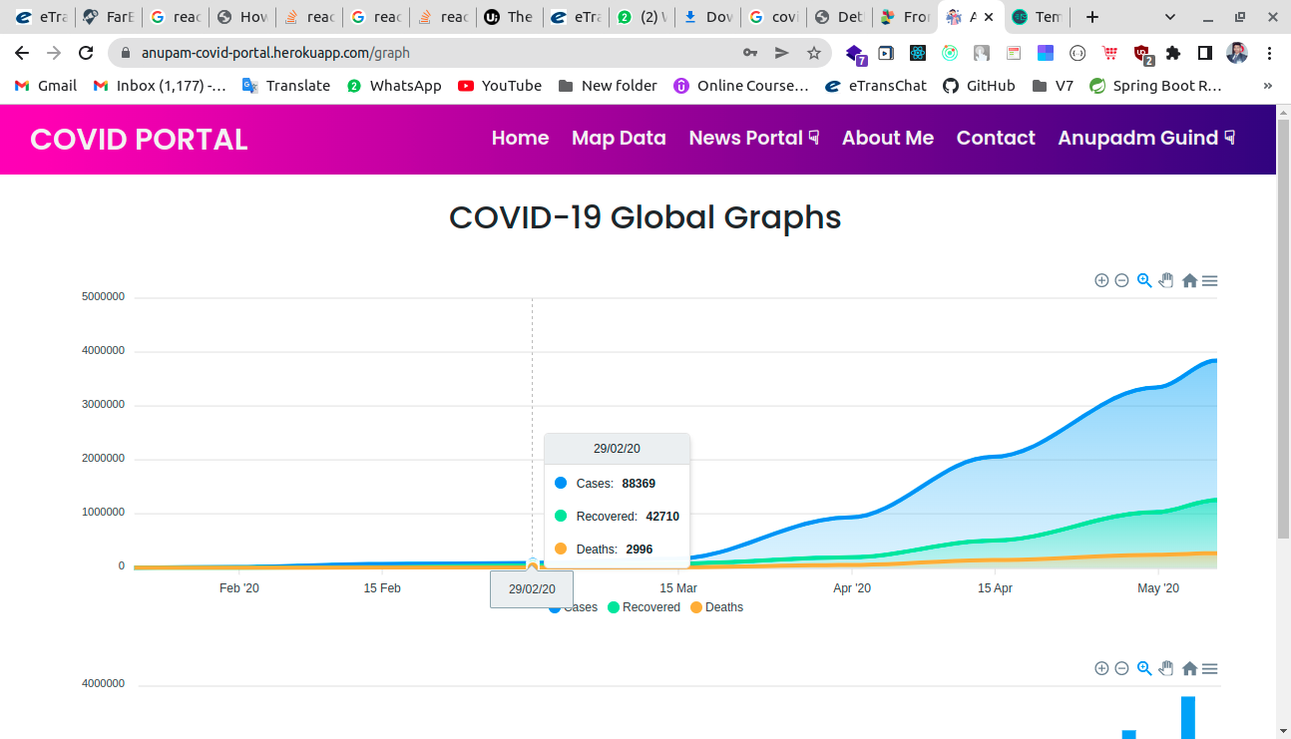

**CHAPTER – 2**

**GRAPH**

**Section 2.1**

**INTRODUCTION :-**

Conclusions In this paper, we have looked through students reports to find out what was affected as a result of the lockdown caused by COVID-19. This was our attempt to see the affects from a broad angle, considering who, what and how perspectives: who is affected, what is affected and how is affected. This is a sort of case study that asserts the problems and challenges that the students faced, not solutions to the problems. However, we offer our analysis and interpretation, so that future researchers in both project-course education and software project management can proceed with best practices and process for project work under a pandemic scenario. Especially educators can find tips on how to avoid them, how to prepare the students and teachers and how to design the course in a way that reduce the impact of these problems.

This ABOUT contains About Us page in the webpage.

**Section 2.2**

**HEAD PART :-**

We used here meta tag to specify character set, page description, keywords, author of the document, and viewport settings.

We use here title tag to show “SoftTech page” which is written inbetween title tag is shown by the search engine. Here we use the script defer src which is specifies that the script is executed when the page has finished parsing then use so many link tag to link many files like bootstrap and css styles etc.Finally this header part is take the whole web page and shown in the browser like chrome.

package com.anupam.CovidPortal.controller;

import java.util.HashMap;

import java.util.Map;

import javax.validation.Valid;

import org.springframework.beans.factory.annotation.Autowired;

import org.springframework.http.HttpStatus;

import org.springframework.http.ResponseEntity;

import org.springframework.validation.BindingResult;

import org.springframework.validation.FieldError;

import org.springframework.web.bind.annotation.CrossOrigin;

import org.springframework.web.bind.annotation.GetMapping;

import org.springframework.web.bind.annotation.PostMapping;

import org.springframework.web.bind.annotation.RequestBody;

import org.springframework.web.bind.annotation.RequestMapping;

import org.springframework.web.bind.annotation.RestController;

import com.anupam.CovidPortal.model.ContactForm;

import com.anupam.CovidPortal.serviceImpl.FirstService;

import com.anupam.CovidPortal.serviceImpl.MapValidationErrorService;

@RestController

@RequestMapping("/first")

//@CrossOrigin(origins = "*", allowedHeaders = "*")

public class FirstController {

@Autowired

MapValidationErrorService mapValidationErrorService;

@Autowired

FirstService firstService;

@GetMapping("/one")

public String one() {

return "Hi ANupam Guin";

}

@PostMapping("/contactForm")

public ResponseEntity<?> contactForm(@Valid @RequestBody ContactForm contact, BindingResult bindingResult) {

Map<String,Object> map=new HashMap<>();

if (bindingResult.hasErrors()) {

Map<String, String> errorMap = new HashMap<String,String>();

for (FieldError error : bindingResult.getFieldErrors()) {

errorMap.put(error.getField(), error.getDefaultMessage());

System.out.println(errorMap);

}

return new ResponseEntity<Map<String, String>>(errorMap, HttpStatus.CONFLICT);

}

try {

firstService.saveContactForm(contact);

map.put("message", true);

return ResponseEntity.status(HttpStatus.ACCEPTED).body(map);

} catch (Exception e) {

map.put("message", false);

return ResponseEntity.status(HttpStatus.CHECKPOINT).body(map);

}

}

}

**HEAD PART CODE :-**

**Section 2.3**

**BODY PART :-**

Here give the backend Code

@PostMapping("/login")

**public** ResponseEntity<?> login(@Valid @RequestBody LoginRequestModel loginModel, BindingResult bindingResult) {

System.***out***.println(loginModel);

ResponseEntity<?> errorMap = mapValidationErrorService.mapValidationService(bindingResult);

**if** (errorMap != **null**)

**return** errorMap;

**try** {

authenticationManager.authenticate(

**new** UsernamePasswordAuthenticationToken(loginModel.getUsername(), loginModel.getPassword()));

} **catch** (Exception e) {

**return** ResponseEntity.*status*(HttpStatus.***UNAUTHORIZED***).body(**new** LoginResponseModel(**false**));

}

**return** ResponseEntity.*ok*(**new** LoginResponseModel(**true**, jwtUtil.generateToken(loginModel.getUsername())));

}

@PostMapping("/register")

**public** ResponseEntity<?> register(@Valid @RequestBody RegisterModel registerModel, BindingResult bindingResult) {

// Validate passwords match

userValidator.validate(registerModel, bindingResult);

System.***out***.println(registerModel);

ResponseEntity<?> errorMap = mapValidationErrorService.mapValidationService(bindingResult);

**if** (errorMap != **null**)

**return** errorMap;

Map<String, Object> map = **new** HashMap<String, Object>();

**try** {

// int otp = (int)(double) (Math.random() * 1000000);

**int** otp = **new** Random().nextInt(999999);

System.***out***.println(otp);

String header = "Covid Portal OTP from Anupam";

String body = "Hi," + registerModel.getName() + "\n Your Covid Portal OTP is : " + otp

+ "\n Thanks For Your Registration on this Portal Dear " + registerModel.getName()

+ ". We think that You will be Stay at your Home. \n Yours Faithfully, Anupam Guin ( FullStack Software Engineer )";

**boolean** b = userService.sendOtpEmail(registerModel.getEmail(), body, header);

**int** key = (**int**) (**double**) (Math.*random*() * 1000000000);

registerModel.setId(key);

registerModel.setOtp(otp);

userService.saveUser(registerModel);

map.put("success", b);

map.put("id", key);

**return** ResponseEntity.*ok*(map);

} **catch** (Exception e) {

map.put("success", **false**);

**return** ResponseEntity.*status*(HttpStatus.***NO_CONTENT***).body(map);

}

}

@GetMapping("/otp")

**public** ResponseEntity<?> otp(@RequestParam(name = "id", defaultValue = "0") **int** id,

@RequestParam(name = "otp", defaultValue = "0") **int** otp) {

OtpResponseModel orm;

Map<String, Object> map = **new** HashMap<String, Object>();

map.put("success", **false**);

**try** {

orm = userService.checkOtp(id, otp);

**if** (orm != **null**) {

map.put("success", **true**);

**return** ResponseEntity.*status*(HttpStatus.***CREATED***).body(map);

}

**return** ResponseEntity.*status*(HttpStatus.***BAD_REQUEST***).body(map);

} **catch** (Exception e) {

e.printStackTrace();

**return** ResponseEntity.*status*(HttpStatus.***BAD_REQUEST***).body(map);

}

}

}

***Subsection 2.3.a***

**MAIN NAV BAR :-**

@Override

**public** UserDetails loadUserByUsername(String username) **throws** UsernameNotFoundException {

OtpResponseModel userEntity = otpRepo.findByEmail(username);

**if** (userEntity == **null**)

**throw** **new** UsernameNotFoundException("Username not found");

**return** **new** org.springframework.security.core.userdetails.User(userEntity.getEmail(),

userEntity.getPassword(), **new** ArrayList<>());

}

***Subsection 2.3.b***

**ABOUT US INTRO :-**

This Security Another Part

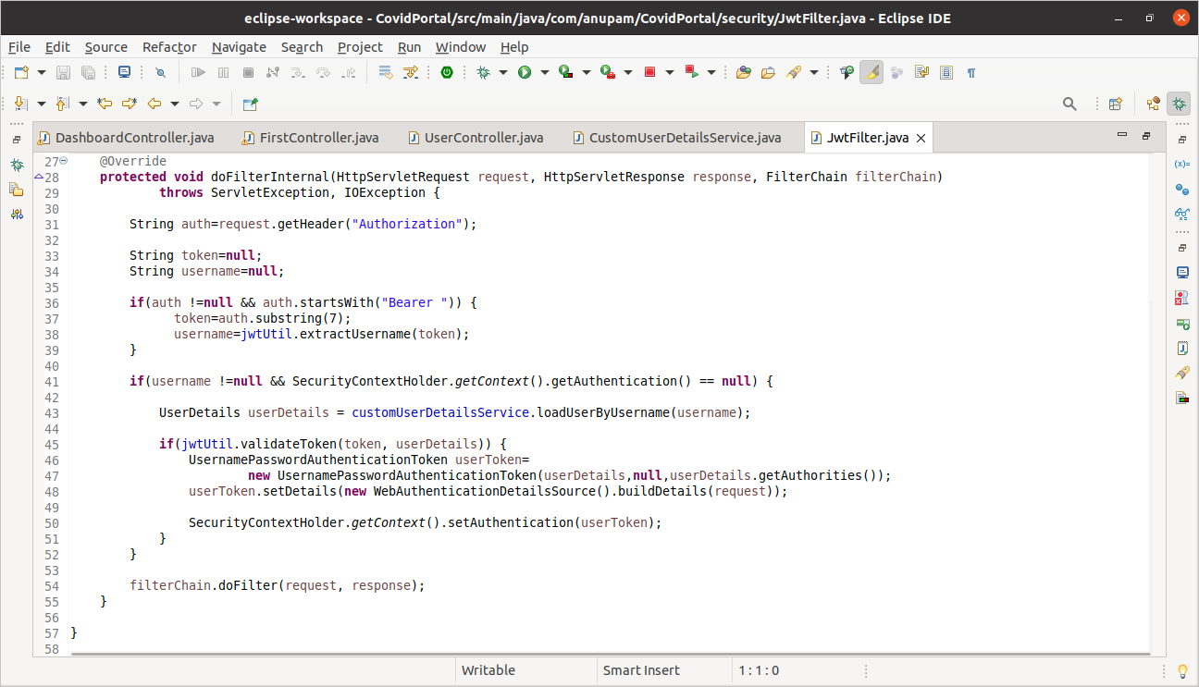

***Subsection 2.3.c***

**ABOUT US SECTION:-**

This Is Token Creation and Validation in Spring Security

@Bean(name = BeanIds.***AUTHENTICATION_MANAGER***) // This is create bean for @Autowired AuthenticationManager

// in WelcomeController class

**public** AuthenticationManager authenticationManager() **throws** Exception {

**return** **super**.authenticationManager();

}

@Override

**protected** **void** configure(HttpSecurity http) **throws** Exception {

http.cors(); // TO disable CORS

http.csrf().disable();

http.authorizeRequests()

.and().headers().frameOptions().sameOrigin() // To enable H2 database

.and()

.authorizeRequests()

.antMatchers(

"/",

"/favicon.ico",

"/**/*.png",

"/**/*.gif",

"/**/*.svg",

"/**/*.jpg",

"/**/*.html",

"/**/*.css",

"/**/*.js"

).permitAll().

antMatchers("/user/**").permitAll()

.anyRequest().authenticated()

.and().exceptionHandling()

.and().sessionManagement().

sessionCreationPolicy(SessionCreationPolicy.***STATELESS***);

http.addFilterBefore(jwtFilter,UsernamePasswordAuthenticationFilter.**class**);

}

@Override

**protected** **void** configure(AuthenticationManagerBuilder auth) **throws** Exception {

auth.userDetailsService(customUserDetailsService);

}

***Subsection 2.3.d***

**package** com.anupam.CovidPortal.model;

**import** javax.validation.constraints.NotBlank;

**public** **class** LoginRequestModel {

@NotBlank(message = "Username must not be Blank")

**private** String username;

@NotBlank(message = "Password must not be Blank")

**private** String password;

**public** String getUsername() {

**return** username;

}

**public** **void** setUsername(String username) {

**this**.username = username;

}

**public** String getPassword() {

**return** password;

}

**public** **void** setPassword(String password) {

**this**.password = password;

}

@Override

**public** String toString() {

**return** "LoginModel [username=" + username + ", password=" + password + "]";

}

}

***Subsection 2.3.e***

**MAIN FOOTER :-**

In between main footer the used tags are footer tag, div tag, heading tag, anchor tag.Then this main footer is over.

package com.anupam.CovidPortal.model;

import javax.persistence.Column;

import javax.persistence.Entity;

import javax.persistence.Id;

import javax.persistence.Table;

import javax.persistence.Transient;

import javax.validation.constraints.Email;

import javax.validation.constraints.NotBlank;

@Entity

@Table(name = "user_final_table")

public class OtpResponseModel {

@Id

private int id;

@Column

@NotBlank(message = "Name is Required")

private String name;

@Email(message = "Invalid Email")

@NotBlank(message = "Email is not be Blank")

@Column(unique = true,length=32)

private String email;

@NotBlank(message = "Mobile is not be empty")

@Column()

private String mobile;

@Column()

private int age;

@NotBlank(message = "Password field is Required")

@Column

private String password;

public int getId() {

return id;

}

public void setId(int id) {

this.id = id;

}

public String getPassword() {

return password;

}

public void setPassword(String password) {

this.password = password;

}

public String getName() {

return name;

}

public void setName(String name) {

this.name = name;

}

public String getEmail() {

return email;

}

public void setEmail(String email) {

this.email = email;

}

public String getMobile() {

return mobile;

}

public void setMobile(String mobile) {

this.mobile = mobile;

}

public int getAge() {

return age;

}

public void setAge(int age) {

this.age = age;

}

@Override

public String toString() {

return "OtpResponse [id=" + id + ", name=" + name + ", email=" + email + ", mobile=" + mobile + ", age=" + age

+ ", password=" + password + "]";

}

public OtpResponseModel() {

super();

// TODO Auto-generated constructor stub

}

public OtpResponseModel(int id, @NotBlank(message = "Name is Required") String name,

@Email(message = "Invalid Email") @NotBlank(message = "Email is not be Blank") String email,

@NotBlank(message = "Mobile is not be empty") String mobile, int age,

@NotBlank(message = "Password field is Required") String password) {

super();

this.id = id;

this.name = name;

this.email = email;

this.mobile = mobile;

this.age = age;

this.password = password;

}

}

***Subsection 2.3.f***

**CONTACT MODAL :-**

In between contact modal the used tags are div tag, heading tag, botton tag, form tag, input tag, text-area tag, i tag . Then this contact modal is over.

<!-- Contact Modal -->

<div class="modal" id="contact-modal">

    <div class="modal-dialog">

        <div class="modal-content animated zoomInUp">

            <div class="modal-header bg-warning text-white">

                <h3>Contact Us</h3>

                <button class="close" data-dismiss="modal">

                    <i class="fa fa-times-circle"></i>

                </button>

            </div>

            <div class="modal-body bg-light">

                <form>

                    <div class="form-group">

                        <input type="text" class="form-control" placeholder="User Name">

                    </div>

                    <div class="form-group">

                        <input type="email" class="form-control" placeholder="Email">

                    </div>

                    <div class="form-group">

                        <textarea rows="4" class="form-control" placeholder="Description"></textarea>

                    </div>

                    <input type="submit" value="Contact" class="btn btn-warning">

                    <a href="#" class="btn btn-warning" data-dismiss="modal">Close</a>

                </form>

            </div>

        </div>

    </div>

</div>

***Subsection 2.3.g***

**OPTIONAL JAVASCRIPT :-**

In between optional javascript some script tag are added here and inbetween these script jQuery , popper , bootstrap files are added here.Then this part also over.

<!-- Optional JavaScript -->

<!-- jQuery first, then Popper.js, then Bootstrap JS -->

<!-- BODY ENDS -->

<script src="../../bootstrap/js/jquery-3.3.1.min.js"></script>

<script src="../../bootstrap/js/popper.min.js"></script>

<script src="../../bootstrap/js/bootstrap.min.js"></script>

<script src="../../bootstrap/js/mdb.min.js"></script>

<script src="https://cdnjs.cloudflare.com/ajax/libs/ekko-lightbox/5.3.0/ekko-lightbox.js"></script>

<script>

    $(document).on('click', '[data-toggle="lightbox"]', function(event) {

        event.preventDefault();

        $(this).ekkoLightbox();

    });

</script>

OUTPUT OF THE ABOUT US PAGE :-

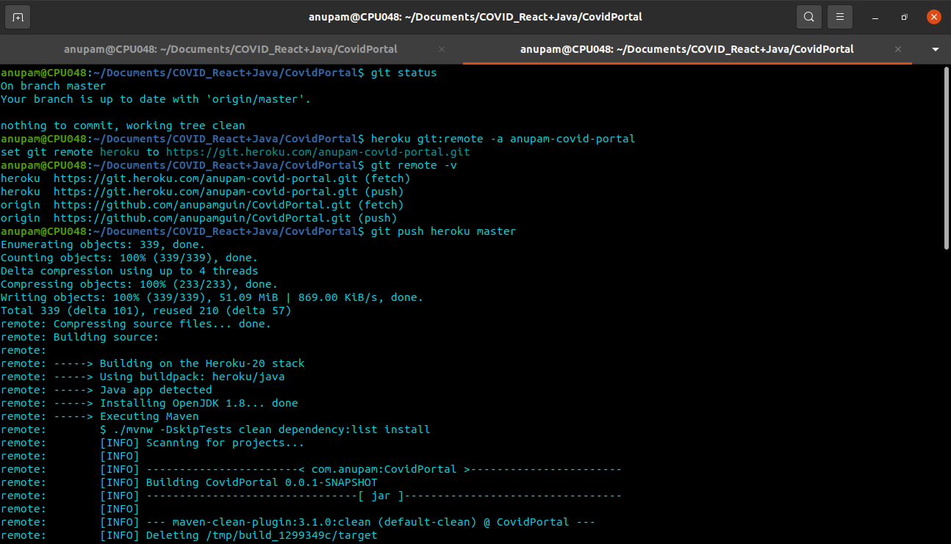

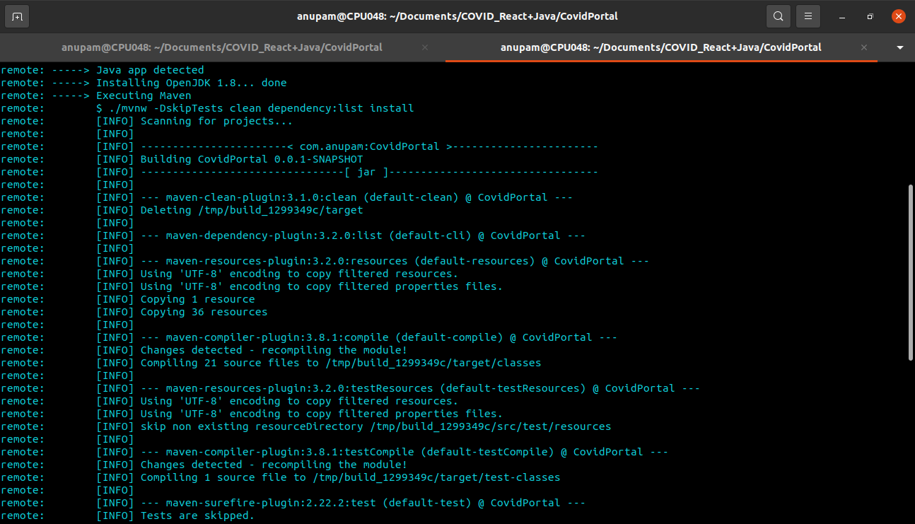

**CHAPTER – 3**

**Redux**

**Section 3.1**

**INTRODUCTION :-**

It is used to design web pages using a markup language. HTML is the combination of Hypertext and Markup language. Hypertext defines the link between the web pages. A markup language is used to define the text document within tag which defines the structure of web pages. This language is used to annotate (make notes for the computer) text so that a machine can understand it and manipulate text accordingly. Most markup languages (e.g. HTML) are human-readable. The language uses tags to define what manipulation has to be done on the text.

HTML is a markup language used by the browser to manipulate text, images, and other content, in order to display it in the required format. HTML was created by Tim Berners-Lee in 1991. The first-ever version of HTML was HTML 1.0, but the first standard version was HTML 2.0, published in 1999.

This COURSES.HTML contains COURSES page in the webpage.Where user can know all about courses.

**Section 3.2**

**HEAD PART :-**

We used here meta tag to specify character set, page description, keywords, author of the document, and viewport settings.

We use here title tag to show “SoftTech page” which is written inbetween title tag is shown by the search engine. Here we use the script defer src which is specifies that the script is executed when the page has finished parsing then use so many link tag to link many files like bootstrap and css styles etc.Finally this header part is take the whole web page and shown in the browser like chrome.

<head>

    <meta charset="UTF-8">

    <meta name="viewport" content="width=device-width, initial-scale=1.0">

    <meta http-equiv="X-UA-Compatible" content="ie=edge">

    <link rel="stylesheet" href="https://use.fontawesome.com/releases/v5.8.1/css/all.css" integrity="sha384-50oBUHEmvpQ+1lW4y57PTFmhCaXp0ML5d60M1M7uH2+nqUivzIebhndOJK28anvf" crossorigin="anonymous">

    <link rel="stylesheet" href="../../bootstrap/css/font-awesome-5.8.1.css">

    <link rel="stylesheet" href="../../bootstrap/css/bootstrap.css">

    <link rel="stylesheet" href="../../bootstrap/css/mdb.css">

    <link rel="stylesheet" href="../../bootstrap/css/style.css">

    <link rel="stylesheet" href="https://cdnjs.cloudflare.com/ajax/libs/ekko-lightbox/5.3.0/ekko-lightbox.css">

    <link rel="stylesheet" href="../css/styles.css">

    <title>SoftTech Page</title>

</head>

**Section 3.3**

**BODY PART :-**

There are so many body tags are used in our index file like nav tag, div tag, section tag and footer tag.

This body part is described elaborately by us let’s see in below -

***Subsection 3.3.a***

**MAIN NAV BAR :-**

In between main nav bar there are so many html tags are used here like nav tag , div tag, anchor tag and inbetween anchor tag there is a image tag.buttons are used here inbetween botton there is a span tag .Then the ul tag and li tags are used here to make a nav bar.

package com.anupam.CovidPortal.validator;

import org.springframework.stereotype.Component;

import org.springframework.validation.Errors;

import org.springframework.validation.Validator;

import com.anupam.CovidPortal.model.RegisterModel;

@Component

public class UserValidator implements Validator{

@Override

public boolean supports(Class<?> clazz) {

return RegisterModel.class.equals(clazz);

}

@Override

public void validate(Object object, Errors errors) {

RegisterModel user=(RegisterModel) object;

if(user.getPassword().length() < 6) {

errors.rejectValue("password","Length","Password must be at least 6 Characters");

}

if(!user.getPassword().equals(user.getConfirmPassword())) {

errors.rejectValue("confirmPassword","Match","Password must be match");

}

}

}

***Subsection 3.3.b***

**COURSES SECTION :-**

In courses the used tags are section tag, div tag, header tag and hr tag.

package com.anupam.CovidPortal.serviceImpl;

import java.util.HashMap;

import java.util.Map;

import org.springframework.http.HttpStatus;

import org.springframework.http.ResponseEntity;

import org.springframework.stereotype.Service;

import org.springframework.validation.BindingResult;

import org.springframework.validation.FieldError;

@Service

public class MapValidationErrorService {

public ResponseEntity<?> mapValidationService(BindingResult result){

if(result.hasErrors()) {

Map<String,String> errorMap = new HashMap<>();

for(FieldError error : result.getFieldErrors())

{

errorMap.put(error.getField(), error.getDefaultMessage());

}

return new ResponseEntity<Map<String,String>>(errorMap,HttpStatus.BAD_REQUEST);

}

return null;

}

}

***Subsection 3.3.c***

**COURSES SERVICE SECTION :-**

In courses the used tags are section tag, div tag, anchor tag, image tag, header tag , paragraph tag.

<!-- Courses service Section -->

<section class="p-4">

    <div class="container">

        <div class="row align-items-center">

            <div class="col-md-6">

                <a href="../img/services.jpg" data-toggle="lightbox">

                    <img src="../img/services.jpg" class="img-fluid c-image" alt="">

                </a>

            </div>

            <div class="col-md-6">

                <h2 class="font-weight-bold text-warning">Our Services</h2>

                 <p class="lead">I advice you to go for SoftTech , as many of my classmates and friends have joined that. All of them have got placed at min. Package of 3 Lacs.Yes, you have to study for selection and the hard work you can do, cannot be done by anyone else for you. I joined SoftTech, I advice you to go for SoftTech , as many of my classmates and friends have joined that. All of them have got placed at min. Package of 3 Lacs.Yes, you have to study for selection and the hard work you can do, cannot be done by anyone else for you. I joined SoftTech, Bhubaneswar,Odisha in Jan, 2021 . At that time, 120 students were in a class. At that time, 120 students were in a class.</p>

            </div>

        </div>

    </div>

</section>

***Subsection 3.3.d***

**COURSES DETAILS SECTION :-**

In courses the used tags are section tag, div tag, header tag , hr tag, I tag, paragraph tag.

<!-- Course Details Section -->

<section class="p-3">

    <div class="container">

        <div class="row">

            <div class="col">

                <h2>Course Details</h2>

                <hr>

            </div>

        </div>

        <div class="row text-center">

            <div class="col-md-3">

                <div class="card c_card">

                    <div class="card-body">

                        <i class="fa fa-coffee fa-4x"></i>

                        <h3>Java Training</h3>

                         <p class="lead">I advice you to go for SoftTech , as many of my classmates and friends have joined that. All of them have got placed at min. Package of 3 Lacs.</p>

                    </div>

                </div>

            </div>

            <div class="col-md-3">

                <div class="card c_card">

                    <div class="card-body">

                        <i class="fa fa-images fa-4x"></i>

                        <h3>Ui Development</h3>

                        <p class="lead">I advice you to go for SoftTech , as many of my classmates and friends have joined that. All of them have got placed at min. Package of 3 Lacs.</p>

                    </div>

                </div>

            </div>

            <div class="col-md-3">

                <div class="card c_card">

                    <div class="card-body">

                        <i class="fa fa-code fa-4x"></i>

                        <h3>Angular Training</h3>

                        <p class="lead">I advice you to go for SoftTech , as many of my classmates and friends have joined that. All of them have got placed at min. Package of 3 Lacs.</p>

                    </div>

                </div>

            </div>

            <div class="col-md-3">

                <div class="card c_card">

                    <div class="card-body">

                        <i class="fa fa-database fa-4x"></i>

                        <h3>MongoDB</h3>

                        <p class="lead">I advice you to go for SoftTech , as many of my classmates and friends have joined that. All of them have got placed at min. Package of 3 Lacs.</p>

                    </div>

                </div>

            </div>

        </div>

        <div class="row text-center mt-4">

            <div class="col-md-3">

                <div class="card c_card">

                    <div class="card-body">

                        <i class="fa fa-leaf fa-4x"></i>

                        <h3>MEAN Stack</h3>

                         <p class="lead">I advice you to go for SoftTech , as many of my classmates and friends have joined that. All of them have got placed at min. Package of 3 Lacs.</p>

                    </div>

                </div>

            </div>

            <div class="col-md-3">

                <div class="card c_card">

                    <div class="card-body">

                        <i class="fa fa-brain fa-4x"></i>

                        <h3>Data Science</h3>

                        <p class="lead">I advice you to go for SoftTech , as many of my classmates and friends have joined that. All of them have got placed at min. Package of 3 Lacs.</p>

                    </div>

                </div>

            </div>

            <div class="col-md-3">

                <div class="card c_card">

                    <div class="card-body">

                        <i class="fab fa-node-js fa-4x"></i>

                        <h3>Node JS Training</h3>

                        <p class="lead">I advice you to go for SoftTech , as many of my classmates and friends have joined that. All of them have got placed at min. Package of 3 Lacs.</p>

                    </div>

                </div>

            </div>

            <div class="col-md-3">

                <div class="card c_card">

                    <div class="card-body">

                        <i class="fab fa-bootstrap fa-4x"></i>

                        <h3>Bootstrap</h3>

                       <p class="lead">I advice you to go for SoftTech, as many of my classmates and friends have joined that. All of them have got placed at min. Package of 3 Lacs.</p>

                    </div>

                </div>

            </div>

        </div>

    </div>

</section>

***Subsection 3.3.e***

**PRICE DETAILS SECTION :-**

In courses the used tags are section tag, div tag, header tag , hr tag, paragraph tag, ul tag, li tag.

<!-- Price Details Section -->

<section class="p-3">

    <div class="container">

        <div class="row">

            <div class="col">

                <h2>Price Details</h2>

                <hr>

            </div>

        </div>

        <div class="row">

            <div class="col-md-4">

                <div class="card text-center">

                    <div class="card-header bg-success text-white">

                        <h3>Silver Plan</h3>

                    </div>

                    <div class="card-body">

                        <h3>&#8377; 10,000 Month</h3>

                        <p class="lead">I advice you to go for SoftTech , as many of my classmates and friends have joined that.</p>

                        <ul class="list-group">

                            <li class="list-group-item list-group-item-action list-group-item-success">

                                <i class="fa fa-check-circle"></i> Course Item 1

                            </li>

                            <li class="list-group-item list-group-item-action list-group-item-danger">

                                <i class="fa fa-times-circle"></i> Course Item 2

                            </li>

                            <li class="list-group-item list-group-item-action list-group-item-danger">

                                <i class="fa fa-times-circle"></i> Course Item 3

                            </li>

                            <li class="list-group-item list-group-item-action list-group-item-danger">

                                <i class="fa fa-times-circle"></i> Course Item 4

                            </li>

                            <li class="list-group-item list-group-item-action list-group-item-success">

                                <i class="fa fa-check-circle"></i> Course Item 5

                            </li>

                        </ul>

                        <a href="#" class="btn btn-success btn-block mt-3">Enroll</a>

                    </div>

                    <div class="card-footer">

                        <h3 class="text-success">1 Year Plan</h3>

                    </div>

                </div>

            </div>

            <div class="col-md-4">

                <div class="card text-center">

                    <div class="card-header bg-primary text-white">

                        <h3>Gold Plan</h3>

                    </div>

                    <div class="card-body">

                        <h3>&#8377; 15,000 Month</h3>

                        <p class="lead">I advice you to go for SoftTech , as many of my classmates and friends have joined that. </p>

                        <ul class="list-group">

                            <li class="list-group-item list-group-item-action list-group-item-success">

                                <i class="fa fa-check-circle"></i> Course Item 1

                            </li>

                            <li class="list-group-item list-group-item-action list-group-item-success">

                                <i class="fa fa-check-circle"></i> Course Item 2

                            </li>

                            <li class="list-group-item list-group-item-action list-group-item-success">

                                <i class="fa fa-check-circle"></i> Course Item 3

                            </li>

                            <li class="list-group-item list-group-item-action list-group-item-danger">

                                <i class="fa fa-times-circle"></i> Course Item 4

                            </li>

                            <li class="list-group-item list-group-item-action list-group-item-success">

                                <i class="fa fa-check-circle"></i> Course Item 5

                            </li>

                        </ul>

                        <a href="#" class="btn btn-primary btn-block mt-3">Enroll</a>

                    </div>

                    <div class="card-footer">

                        <h3 class="text-primary">1 Year Plan</h3>

                    </div>

                </div>

            </div>

            <div class="col-md-4">

                <div class="card text-center">

                    <div class="card-header bg-warning text-white">

                        <h3>Platinum Plan</h3>

                    </div>

                    <div class="card-body">

                        <h3>&#8377; 30,000 Month</h3>

                       <p class="lead">I advice you to go for SoftTech , as many of my classmates and friends have joined that.</p>

                        <ul class="list-group">

                            <li class="list-group-item list-group-item-action list-group-item-success">

                                <i class="fa fa-check-circle"></i> Course Item 1

                            </li>

                            <li class="list-group-item list-group-item-action list-group-item-success">

                                <i class="fa fa-check-circle"></i> Course Item 2

                            </li>

                            <li class="list-group-item list-group-item-action list-group-item-success">

                                <i class="fa fa-check-circle"></i> Course Item 3

                            </li>

                            <li class="list-group-item list-group-item-action list-group-item-success">

                                <i class="fa fa-check-circle"></i> Course Item 4

                            </li>

                            <li class="list-group-item list-group-item-action list-group-item-success">

                                <i class="fa fa-check-circle"></i> Course Item 5

                            </li>

                        </ul>

                        <a href="#" class="btn btn-warning btn-block mt-3">Enroll</a>

                    </div>

                    <div class="card-footer">

                        <h3 class="text-warning">1 Year Plan</h3>

                    </div>

                </div>

            </div>

        </div>

    </div>

</section>

***Subsection 3.3.f***

**MAIN FOOTER :-**

In between main footer the used tags are footer tag, div tag, heading tag, anchor tag.Then this main footer is over.

<!-- Main Footer -->

<footer class="bg-warning text-white text-center p-3">

    <div class="container">

        <div class="row align-items-center">

            <div class="col-md-9">

                <h3>Copyright © 2021,SoftTech.com</h3>

                <h6>All Rights Reserved</h6>

                <h6>Developed & Maintained by

                    <a class="text-warning" href="#" target="_blank">

                        <i class="fa fa-users"></i>SoftTech</a>

                </h6>

            </div>

            <div class="col-md-3">

                <a href="#" class="btn btn-outline-white btn-block" data-toggle="modal" data-target="#contact-modal">Contact</a>

            </div>

        </div>

    </div>

</footer>

***Subsection 3.3.g***

**CONTACT MODAL :-**

In between contact modal the used tags are div tag, heading tag, botton tag, form tag, input tag, text-area tag, i tag . Then this contact modal is over.

<!-- Contact Modal -->

<div class="modal" id="contact-modal">

    <div class="modal-dialog">

        <div class="modal-content animated zoomInUp">

            <div class="modal-header bg-warning text-white">

                <h3>Contact Us</h3>

                <button class="close" data-dismiss="modal">

                    <i class="fa fa-times-circle"></i>

                </button>

            </div>

            <div class="modal-body bg-light">

                <form>

                    <div class="form-group">

                        <input type="text" class="form-control" placeholder="User Name">

                    </div>

                    <div class="form-group">

                        <input type="email" class="form-control" placeholder="Email">

                    </div>

                    <div class="form-group">

                        <textarea rows="4" class="form-control" placeholder="Description"></textarea>

                    </div>

                    <input type="submit" value="Contact" class="btn btn-warning">

                    <a href="#" class="btn btn-warning" data-dismiss="modal">Close</a>

                </form>

            </div>

        </div>

    </div>

</div>

***Subsection 3.3.h***

**OPTIONAL JAVASCRIPT :-**

import { MAP_COUNTRIES, MAP_COUNTRIES_SAGA } from "../Constants/MapConstants";

export const mapCountries = () => {

return { type: MAP_COUNTRIES };

};

export const mapCountriesSaga = (data) => ({

type: MAP_COUNTRIES_SAGA,

payload: data,

});

import {

DO_LOGIN,

DO_REGISTER,

GET_ERRORS,

LOGIN_SAGA,

REGISTER_SAGA,

OTP_SUBMIT,

OTP_SUBMIT_SAGA,

SET_CURRENT_USER,

RESET,

} from "../Constants/UserConstants";

export const do_login = (data) => ({

type: DO_LOGIN,

payload: data,

});

export const do_register = (data, props) => {

return {

type: DO_REGISTER,

payload: [data, props],

};

};

export const loginApiSaga = (data) => ({

type: LOGIN_SAGA,

payload: data,

});

export const registerApiSaga = (data) => ({

type: REGISTER_SAGA,

payload: data,

});

export const errorReducer = (data) => ({

type: GET_ERRORS,

payload: data,

});

export const otpSubmit = (data, props) => ({

type: OTP_SUBMIT,

payload: [data, props],

});

export const otp_SubmitSaga = (data) => ({

type: OTP_SUBMIT_SAGA,

payload: data,

});

export const setCurrentUser = (data) => ({

type: SET_CURRENT_USER,

payload: data,

});

export const resetReducer = () => ({

type: RESET,

});

OUTPUT OF THE COURSES PAGE :-





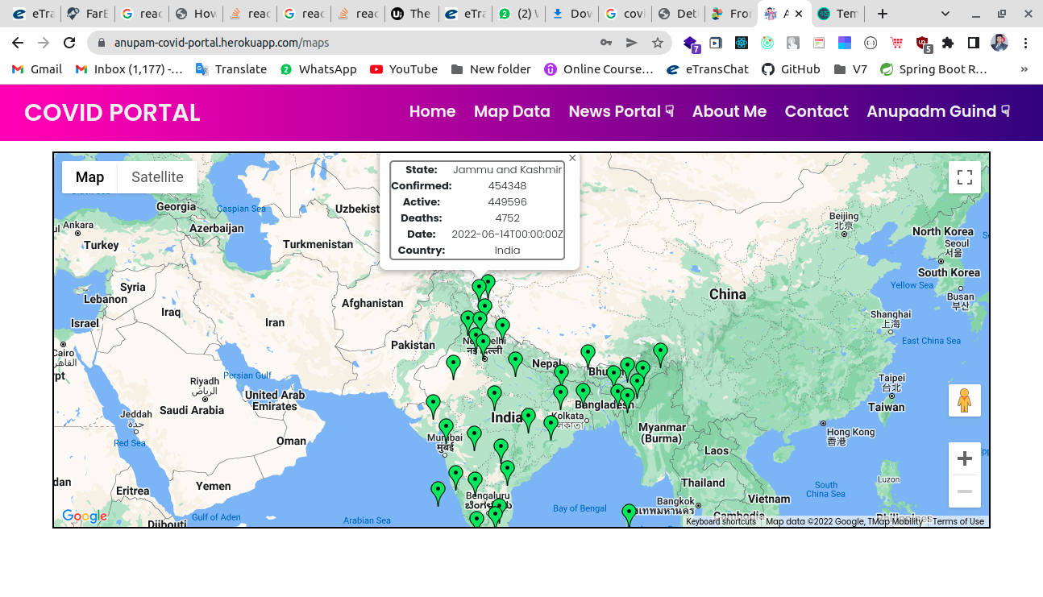



**CHAPTER – 5**

**STYLE.CSS**

**Section 5.1**

**INTRODUCTION :-**

CSS stands for Cascading Style Sheets. CSS describes how HTML elements are to be displayed on screen, paper, or in other media.CSS saves a lot of work. It can control the layout of multiple web pages all at once.External stylesheets are stored in CSS files.

This style.css file is linked to every html page which is available in this website.

**Section 5.2**

**LANDING PAGE STYLES :-**

**CSS applied to all the classes of html .**

@import url("https://fonts.googleapis.com/css2?family=Poppins:wght@200;300;400;500;600;700&display=swap");

* {

margin: 0;

padding: 0;

box-sizing: border-box;

font-family: "Poppins", sans-serif;

}

nav {

position: fixed;

z-index: 99;

width: 100%;

background: linear-gradient(to right, rgb(245, 0, 184), rgb(50, 0, 130));

}

nav .wrapper {

position: relative;

max-width: 1300px;

padding: 0px 30px;

height: 70px;

/* line-height: 70px; */

margin: auto;

display: flex;

align-items: center;

justify-content: space-between;

}

.wrapper .logo a {

color: #f2f2f2;

font-size: 30px;

font-weight: 600;

text-decoration: none;

}

.wrapper .nav-links {

display: inline-flex;

margin-top: 15px !important;

font-weight: 700 !important;

}

.nav-links li {

list-style: none;

}

.nav-links li a {

color: #f2f2f2;

text-decoration: none;

font-size: 1.2rem;

font-weight: 600;

/* padding: 9px 15px; */

padding: 0.4rem 0.7rem;

border-radius: 5px;

transition: all 0.3s ease;

}

.nav-links li a:hover {

background: linear-gradient(to left, rgb(245, 0, 184), rgb(50, 0, 130));

/* 3A3B3C */

border-radius: 20px;

transition: 0.5s;

}

.nav-links .mobile-item {

display: none;

}

.nav-links .drop-menu {

position: absolute;

background: linear-gradient(57deg, #00c6a7, #1e4d92);

/* #262424 */

width: 180px;

line-height: 45px;

top: 85px;

opacity: 0;

visibility: hidden;

box-shadow: 0 6px 10px rgba(0, 0, 0, 0.15);

}

.nav-links li:hover .drop-menu,

.nav-links li:hover .mega-box {

transition: all 0.3s ease;

top: 70px;

opacity: 1;

visibility: visible;

}

.drop-menu li a {

width: 100%;

display: block;

padding: 0 0 0 15px;

font-weight: 400;

border-radius: 0px;

}

.mega-box {

position: absolute;

left: 0;

width: 100%;

padding: 0 30px;

top: 85px;

opacity: 0;

visibility: hidden;

}

.mega-box .content {

background: #242624;

padding: 25px 20px;

display: flex;

width: 100%;

justify-content: space-between;

box-shadow: 0 6px 10px rgba(0, 0, 0, 0.15);

}

.mega-box .content .row {

width: calc(25% - 30px);

line-height: 45px;

}

.content .row img {

width: 100%;

height: 100%;

object-fit: cover;

}

.content .row header {

color: #f2f2f2;

font-size: 20px;

font-weight: 500;

}

.content .row .mega-links {

margin-left: -40px;

border-left: 1px solid rgba(255, 255, 255, 0.09);

}

.row .mega-links li {

padding: 0 20px;

}

**CONCLUSION :-**

In this paper, we have looked through students reports to find out what was affected as a result of the lockdown caused by COVID-19. This was our attempt to see the affects from a broad angle, considering who, what and how perspectives: who is affected, what is affected and how is affected. This is a sort of case study that asserts the problems and challenges that the students faced, not solutions to the problems. However, we offer our analysis and interpretation, so that future researchers in both project-course education and software project management can proceed with best practices and process for project work under a pandemic scenario. Especially educators can find tips on how to avoid them, how to prepare the students and teachers and how to design the course in a way that reduce the impact of these problems. In general, the lockdown situation is supposed to affect the groups with adverse impacts in teamwork, overall progress of the project and the product. Students see the effects directly on the progress of the work through project progress measures such as sprint delivery, burnt down chart, project plan etc. They also see the effects in course achievements through different assignment submissions and project documentation, final product and project delivery.

**-----------------------------------------------0------------------------------------------------**